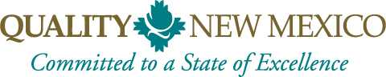  PO Box 93396  Albuquerque, NM 87199 | partner investment  Invoice # __________  Date: __________

From:
Your Name:
Your Company Name:
Your Street Address:
Your City, State and Zip Code:

Instructions:
Select the partnership investment plan that is best for you and your organization.
Partnership Plan name | DESCRIPTION | UNIT PRICE | Check plan
Diamond | 75% discounts on all training and application, customized logo on QNM Website, sponsor of all QNM events | $10,000
Platinum | 50% off all courses and 5 free enrollments, 25% off award application, sponsor of all QNM events, name on partner page | $7,500
Gold | 45% off all courses and 3 free enrollments, 25% off award application, sponsor of application & examiner training events, name on partner page | $5,000
Silver | 30% off all courses and 2 free enrollments, 20% off award application, name on partner page | $3,000
Turquoise | 20% off all courses, 15% off award application, name on partner page | $1,000
Bronze | 20% off all courses, 10% off award application, name on partner page | $500
Iron | 20% off all courses, 5% off award application, name on partner page | $300
Individual | 20% off all courses, name on partner page | $100

TOTAL due
Make all checks payable to Quality New Mexico.
If you have any questions concerning this invoice, contact Maureen Baca, mrbaca@comcast.net 505-450-9371.
Partnership investment plans are effective for one year from date payment is received.

Partner Investments received by September 30th, will receive a 1-year FREE Leadership Learning Series beginning in October, 2021
Thank you for your commitment to a state of Excellence for New Mexico!

